Practical Assignment – 2
Introduction to Web Technology

1. Create a Weekend Checker & display the message on web page accordingly
(Use Switch only)

<html lang="en">
<head> <title>Document</title></head>
<body> <script>
var day = prompt("Enter the day number");
var dayUpadte;
switch (parseInt(day)) {
case 1:
dayUpadte ="Monday";
break;
case 2:
dayUpadte ="Tuesday";
break;
case 3:
dayUpadte ="Wednesday";
break;
case 4:
dayUpadte ="Thursday";
break;
case 5:
dayUpadte ="Friday";
break;
case 6:
dayUpadte ="Saturday";
break;
case 7:
dayUpadte ="Sunday";
break;
default:
dayUpadte = "Invalid day"; // Handle invalid input.
break; }
var dayDefiner;
if (day >6) { dayDefiner = "Weekend , Time to have fun"; }
else { dayDefiner = "Weekday , Time to Work hard" }
alert("Hey It's "+ dayUpadte +" !"+ " "+dayDefiner);
</script>
</body>
</html>
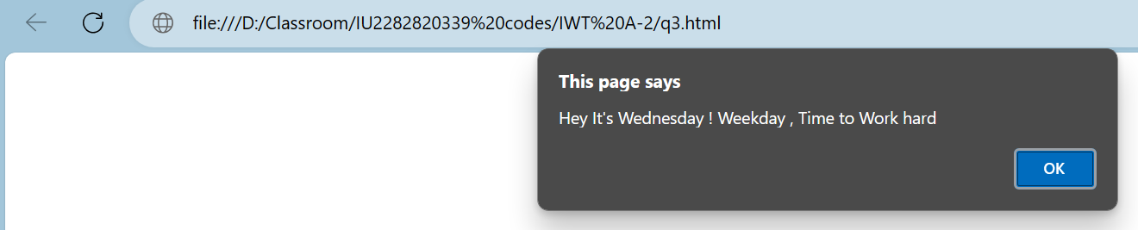

2. Change the background color of your web page according to the button click
<html lang="en">

<head> <title>Document</title>
<script>
function changeColor(colorBtn) {
document.body.style.background = colorBtn; }
function changeHead(colorBtn) {
document.getElementById("heading").style.color = colorBtn; }
</script>
</head>
<body>
<label for="">Select Background color: </label>
<div>
<button id="red" onclick="changeColor('red');">Red</button>
<button id="blue" onclick="changeColor('blue')">Blue</button>
<button id="green" onclick="changeColor('green')">Green</button>
<button id="yellow" onclick="changeColor('yellow')">Yellow</button>
<button id="purple" onclick="changeColor('purple')">Purple</button>
<button id="turqoise" onclick="changeColor('turquoise')">Turquoise</button>
<button id="gray" onclick="changeColor('gray')">Gray</button>
</div>
<hr>
<label for="">Select color for heading: </label>
<div>
<button type="button" ondblclick="changeHead('maroon')">Maroon</button>
<button type="button" ondblclick="changeHead('teal')">Teal</button>
<button type="button" ondblclick="changeHead('orange')">Orange</button>
<button type="button" ondblclick="changeHead('green')">Green</button>
</div>
</body>
</html>

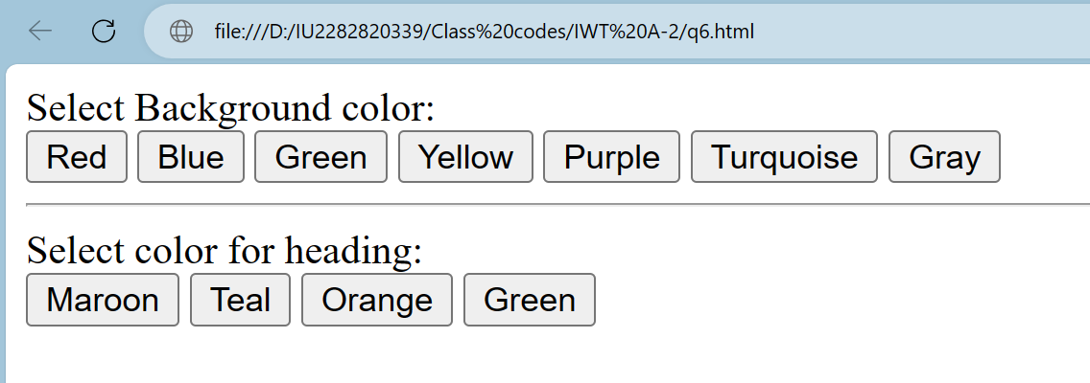

3. Display the image and on click of it provide password protected document.

<html lang="en">
<head>
<meta charset="UTF-8">
<meta name="viewport" content="width=device-width, initial-scale=1.0">
<title>q5</title>
<style>
img{
height: 25rem;
}
body{
background-color:lightslategray ;
}
</style>
<script>
function revelDocument() {
const pass = prompt("Enter the Meth-Lord name:");
if (pass === "heisenberg") {
window.location.href = "meth-recipe.pdf";
} else {
alert("Disappointment");
}
}
</script>
</head>
<body>
<center><img src="meth.png" alt="meth-png" onclick="revelDocument()"></center>
</body>
</html>
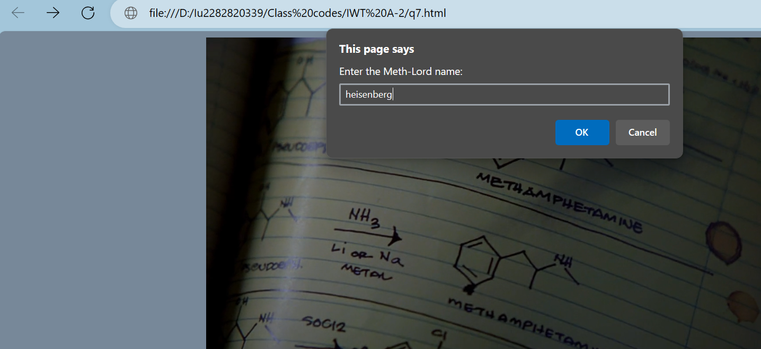
4. Get the username from prompt after 2 seconds display the name in msgbox after 4 seconds.

<html lang="en">
<head>
<meta charset="UTF-8">
<meta name="viewport" content="width=device-width, initial-scale=1.0">
<title>Document</title>
<script>
let name;

setInterval(() => {
name = prompt("Enter name :")
}, 2000);
setInterval(() => {
alert(name);
}, 4000);
</script>
</head>
<body>

</body>
</html>

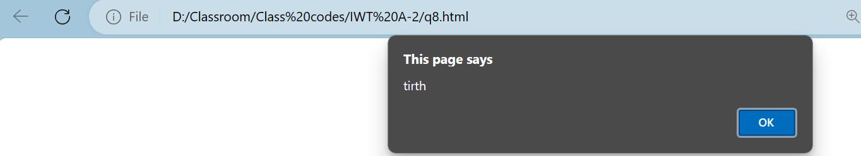

5. Write a JavaScript code block using arrays and generate the current Date in words, this
should include the Day, the Month and the Year. O/P should be as: Monday, August 16,
2010

<html lang="en">
<head>
<meta charset="UTF-8">
<meta name="viewport" content="width=device-width, initial-scale=1.0">
<title>Document</title>
<script>
var weekDays =["Sunday", "Monday", "Tuesday", "Wednesday", "Thursday", "Friday", "Saturday"];
var monthYears =["January", "February", "March", "April", "May", "June", "July", "August", "September", "October", "November", "December"];
var presentDate = new Date();
var day = weekDays[presentDate.getDay()]
var month = monthYears[presentDate.getMonth()]
var dayOfMonth = presentDate.getDate();
var year = presentDate.getFullYear();
alert(day +" "+ month +" "+ dayOfMonth +" "+ year);
</script>
</head>
<body>

</body>
</html>

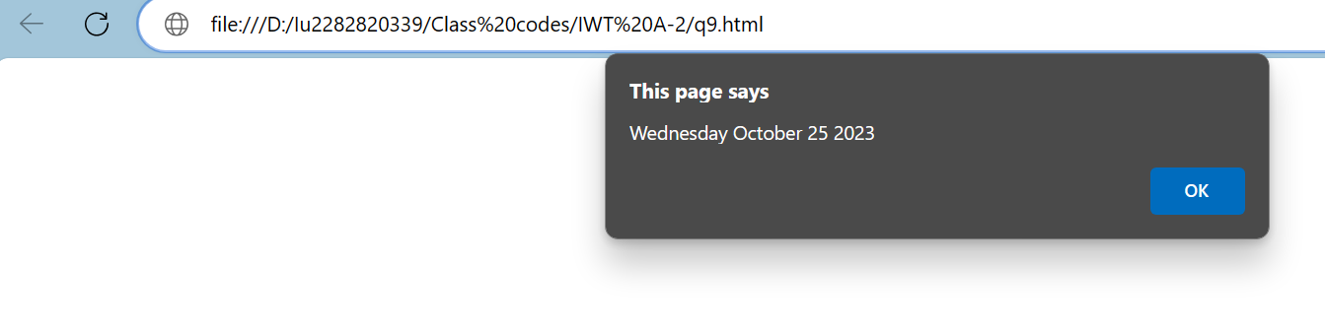

6. Write a code which checks the contents entered in a Form’s Text element. If the text
entered is in the Lowercase, convert to Upper case.

<html lang="en">
<head>
<meta charset="UTF-8">
<meta name="viewport" content="width=device-width, initial-scale=1.0">
<title>Form</title>
<script>
document.addEventListener("DOMContentLoaded",function () {
document.getElementById("submitBtn").addEventListener("click",function () {
const stringGet = document.getElementById("name");
const nameGet = stringGet.value;
const upperCasing = nameGet.toUpperCase();
document.getElementById("output").innerHTML = upperCasing;
})
})
</script>
</head>
<body>
<form>
<table > <tr>
<td><label for="name">Name: </label></td></td>
<td><input type="text" name="name" id="name"></td></td>
</tr> <tr>
<td colspan="2" ><center><button type="button" id="submitBtn">UpperCaseString</button></td>
</tr>
</table>
</form>
<label for="output">Output: </label>
<p id="output"></p>
</body>
</html>

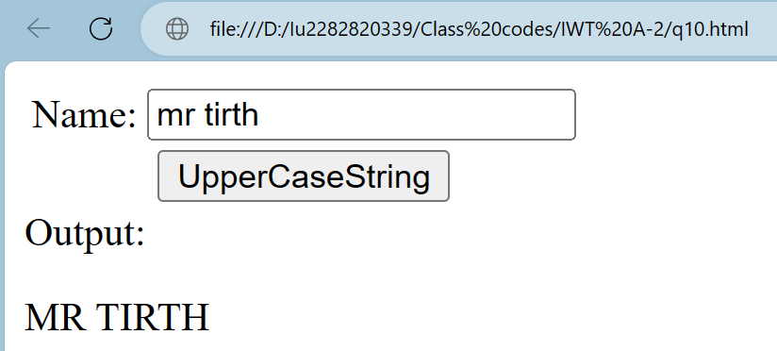
7. Make a function that squares a number. Test it.

<!DOCTYPE html>
<html lang="en">
<head>
<meta charset="UTF-8">
<meta name="viewport" content="width=device-width, initial-scale=1.0">
<title>Square of Number</title>
<script>
function calculateSquare() {
var num = parseFloat(document.getElementById("number").value);
var result = squareOfNumber(num);
document.getElementById("output").textContent = "Square of given number: " + result;
}

function squareOfNumber(num) {
return num * num;
}
</script>
</head>
<body>
<form>
<label for="number">Enter a number: </label>
<input type="number" id="number">
<button type="button" id="submitBtn" onclick="calculateSquare()">Submit</button>
</form>
<p id="output">Square of given number: </p>
</body>
</html>

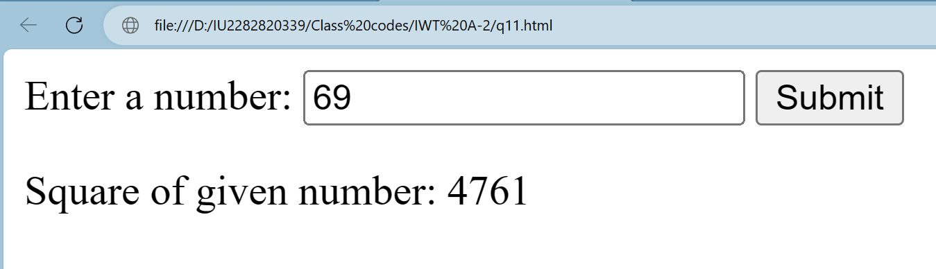

8. Create a Form in HTML with two fields, minimum and maximum, write JavaScript to validate that only numeric value is entered in both, and the value entered in minimum is less than the value entered in maximum.

<html lang="en">
<head>
<meta charset="UTF-8">
<meta name="viewport" content="width=device-width, initial-scale=1.0">
<title>Document</title>
<script>
document.addEventListener("DOMContentLoaded",function () {
document.getElementById("submitBtn").addEventListener("click",function (error) {
error.preventDefault(); // prevent form from submiitting
var minimumNumber = parseFloat(document.getElementById("minNum").value);
var maximumNumber = parseFloat(document.getElementById("maxNum").value);
var display = document.getElementById("output");
if (!isNaN(minimumNumber) && !isNaN(maximumNumber) && minimumNumber < maximumNumber) {
display.textContent = "Validation status: Valid";
} else {
display.textContent = "Validation status: Invalid"; } }) })
</script>
</head>
<body>
<form action="">
<label for="mini">Minimum: </label>
<input type="number" name="minNum" id="minNum">
<br>
<label for="maxi">Maximum: </label>
<input type="number" name="maxNum" id="maxNum">
<br>
<button id="submitBtn">Submit</button>
</form>
<p id="output">Validation status: </p>
</body>
</html>

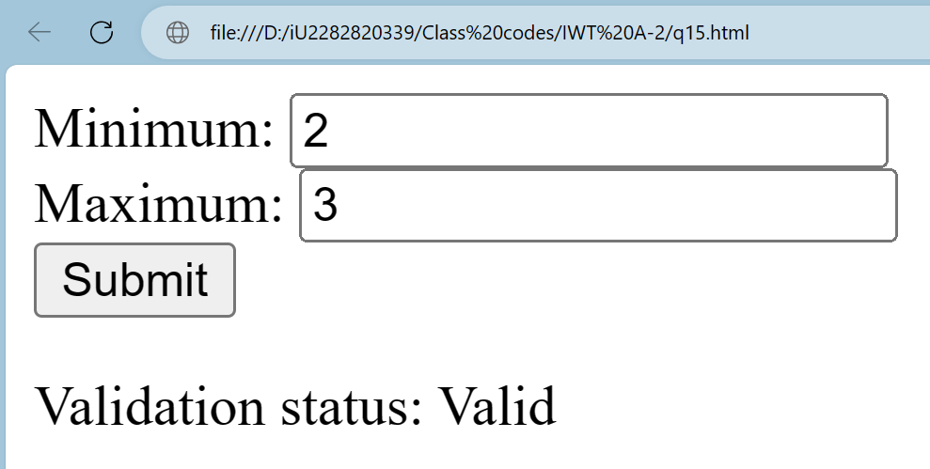

9. Dynamically change the heading at the top of this page. Enter a new title in the Textbox and click the Change button
<!DOCTYPE html>
<html lang="en">
<head>
<meta charset="UTF-8">
<meta name="viewport" content="width=device-width, initial-scale=1.0">
<title>q25</title>
<script>
document.addEventListener("DOMContentLoaded",function () {
function changeHeading() {
const newTitle = document.getElementById("newTitle").value;
const heading = document.getElementById("dynamicHeading");
heading.innerText=newTitle;
}
const changeBtn = document.getElementById("changeBtn");
changeBtn.addEventListener("click", changeHeading);
})
</script>
</head>
<body>
<h1 id="dynamicHeading">Dynamic Deafualt heading</h1>
<label for="newTitle">Enter a new Title: </label>
<input type="text" name="newTitle" id="newTitle">
<button id="changeBtn" onclick="changeHeading()">Change</button>
</body>
</html>

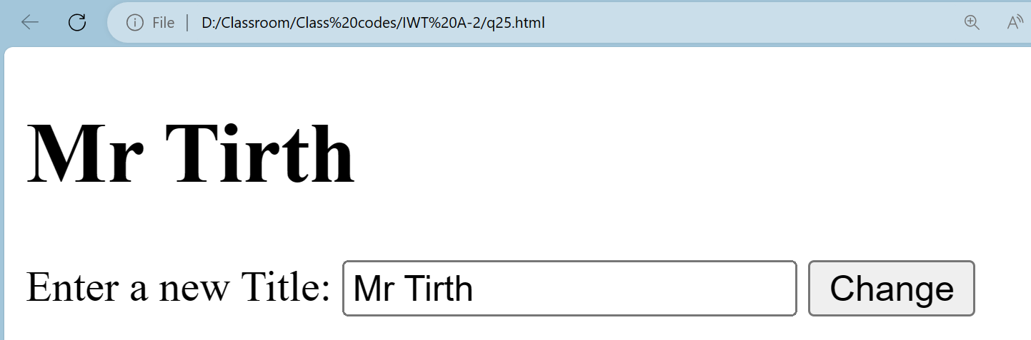

10. Write a JavaScript to generate two random numbers and find out maximum and minimum out of it.

<!DOCTYPE html>
<html lang="en">
<head>
<meta charset="UTF-8">
<meta name="viewport" content="width=device-width, initial-scale=1.0">
<title>Document</title>
</head>
<body>
<p id="output1"></p>
<p id="output2"></p>

<script>
const randomNum1 = Math.floor(Math.random() * 100);
const randomNum2 = Math.floor(Math.random() * 100);
const output1 = document.getElementById("output1");
const output2 = document.getElementById("output2");

output1.innerHTML = "Random Number 1: " + randomNum1;
output2.innerHTML = "Random Number 2: " + randomNum2;

if (randomNum1 < randomNum2) {
alert("The maximum is: " + randomNum2 + "\nThe minimum is: " + randomNum1);
} else if (randomNum1 > randomNum2) {
alert("The maximum is: " + randomNum1 + "\nThe minimum is: " + randomNum2);
} else {
alert("Both numbers are equal: " + randomNum1);
}
</script>
</body>
</html>

